
Leonardo da Vinci

ITI A. Pacinotti | PHASE 2  ANALYSIS OF INDICATORS OF THE WORK MARKET NEEDS  SUMMARY
Dafne Sistemi S.a.s.
babele S.r.l.
Fenice
All Web Solutions S.A.
Universitatea Politehnica din Bucaresti
E.S.S.I.
BDF- Balear de Desarollo Y Formación

INDEX

- INTRODUCTION

- A 2-1 Desk market research on the present situation and the evolutions foreseen for the work market in the Net Economy

- A 2-2 Desk market research on ICT, Communication and the New Economy with reference also to the present situation of employment in Italy and in Europe

- A 2-3 Desk market research on ICT, and media with reference also to the present situation of employment in Italy and in Europe

- A 2-4 Desk market research on the “new companies”(linked to the Net Economy) with reference also to the present situation of employment in Italy and in Europe

- A 2-5 Desk market research on the new companies (dot com: companies born for the developing of the Internet business) linked to the e-Business
- Enterprise Resource Planning,
- Online management of relations with the staff
- Knowledge Management
- Telework
- eLogistic
- Collaborative computing, Workflow, Workgroup
- Supply Chain Management
- On line marketing researches
- Sales Force Automation
- eProcurement
- eGoverment
- eCommerce/Online Banking/Online Insurance
- On line management of R&S projects
- eLearning
- Customer Relationship Management
- Online advertising

- A 2-6 Desk market research on the “IT, Telecom & Internet Related” in the user companies in Italy, with reference also to the present situation of employment in Italy and in Europe

- A 2-7 Acquisition of data from the research market on the use of Internet in order to know the real incidence that this communicative channel can have on the activities under research also in relation with the future development of the web
- The typology of internet sites on the web, classified according to their sector
- The statistical number of internet users, divided according their category
- The type and the number of the most important firms on the web
- The way in which the web is used
- The future prospective of the web development

- A 2-8 Analysis of data acquired through the above-mentioned researches
- Syllabus of the main professional profiles
- BIBLIOGRAPHY

- INTRODUCTION

The data and the analysis about the diffusion of INTERNET and its growing impact in the life of the families and of the firms are known, univocal and ascertained; while the data and the analysis about the rate of application and the effects of the application about the services on line, also called “eBusiness”, are not well ascertained and in same cases are less uniform. The judgement, above all in Italy, is largely affected by the severe crisis that the sector of the ICT industry has suffered in 2002 after a decade of strong growth, but it is important to understand what is the present situation and what are the possibilities of development in the short and medium run, since the ICT usage by enterprises, and not only, has increased both in number and quality.

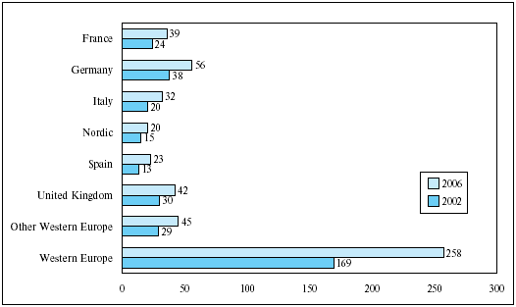
Fig. 1
Web users by country, 2002 and 2006, millions (source: EITO 2003).

In fact, despite the negative trend in the economic world, the progress towards the E-economy has gone on shaping itself according the new trends; the most recent data show that in the EU 95% of the companies in the member states uses computers and that more than 80% has access to the web, these figures are rapidly growing, and that in 2002 already 169 million people had access to the INTERNET, which means 44% of the whole population, and the most accepted forecasts estimate that by 2006 there will be about 258 million Web users in Western Europe (about 962 millions all over the world in 2005).

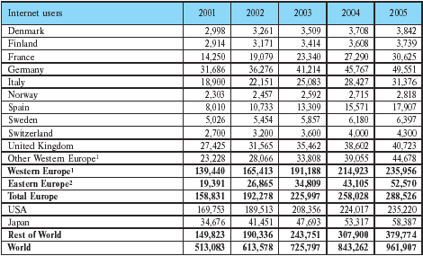
Table 1
Internet users (wire-based), thousands (source: EITO 2003).

Internet users (wire-based)
The number of wire-based users includes all users of the Internet (Web) regardless of their age or whether they have an own account or use one elsewhere. Not included in this number are mobile users and Intranet-only users.

1 Other Western Europe includes Turkey
2 Geographical demarcation

All this means that Europe today is facing a very important challenge, that of improving its economic competitiveness in order to improve and/or promote sustainable economic, social and environmental development; but the economic growth and welfare derive from productivity gains, because it is the productivity gain that creates the space for the increase in wages of the wage earners, the increase in competitiveness for the firms and the increase in the tax base for the governments, and the most up to date economic analyses show that the use of the ICT is the main factor affecting productivity when it is supported by investments in the re-organisation within and between companies and in the human resources skills development and training. According to Bruno Lamborghini (chairman of the EITO): “Europe is spending only a declining portion of the US expenditure for research and development and education. This trend has to be reversed, especially in the ICT area, bearing in mind that the future cycle will be based on intelligence and innovation and only those regions which will have the right skilled human resources (young and old) will have an active part in the new development cycle. Many countries in East Asia have perceived this challenge and are focusing investment on human capital.”. Starting from these consideration and by the fact that in most European countries there an high percentage of highly educated population, the eEurope programme has been launched with the aim of making Europe “the most competitive knowledge-based Society in the world by 2010”. It is interesting to read the eEurope Action Plan for 2005 (European Commission – June 2002) which takes the European E-strategies, since the final aim is that of develop by 2005 modern on line services and a dynamic E-business environment, the Member states are encouraged to adopt all the possible strategies to develop E-government, to promote E-learning, to support E-health and to sustain a dynamic E-business environment, while services, application and content have to be supported by thorough ICT infrastructure including security systems and widespread use of broadband access.
Our aim, in this phase, is that of pointing out through the analysis of the data in our possession, the exigencies of innovation both in the technological field and in the improvement of existing skills and in the training of the new professional profiles. This paper is a summary of the partners’ activities.

- A 2-1 Desk market research on the present situation and the evolutions foreseen for the work market in the Net Economy

In this part of the work, first of all, we give a look to the ICT market in the world then we examine the present employment of the ICT sector in the UE countries compared with the forecasts for the employment in this sector published by The Federation of Finnish Electrical and Electronics Industry for the period 2001-2010. The sector employment is examined both in a scenario of “boom” and one in which the US recession starts a negative trend all over he world.
According to the boom-scenario the whole economic development is favourable and the economy, more or less permanently, moves to all new higher levels of growth. Adaptation of new technologies on both product and business concepts increases. All sectors of the economy invest heavily on ICT products and services. ICT sector’s growth rate is above the average economic growth and the developing towards a real information society accelerates, but the ICT sector’s development, including employment situation, is not similar in all the EU countries because of the structural differences between countries. Pioneer countries (Nordic countries, the Netherlands), that have invested the most in the new technology, witness the fastest growth, but the boom-scenario is so rapid that all EU countries get their share of it. On the other hand in a scenario where the US economy falls into a deep recession and pulls the whole world economy with it, the global economy growth slows down and the ICT sector and market declines, but the growth in the sector is still above the average growth rate in some countries, while in others, above all in the pioneer countries and those countries that are engaged in ICT exports, the ICT industry is in trouble. But after 5 to 7 years of depression the world economy is turning again towards faster growth path and the ICT industry is everywhere the leading sector of this new growth.

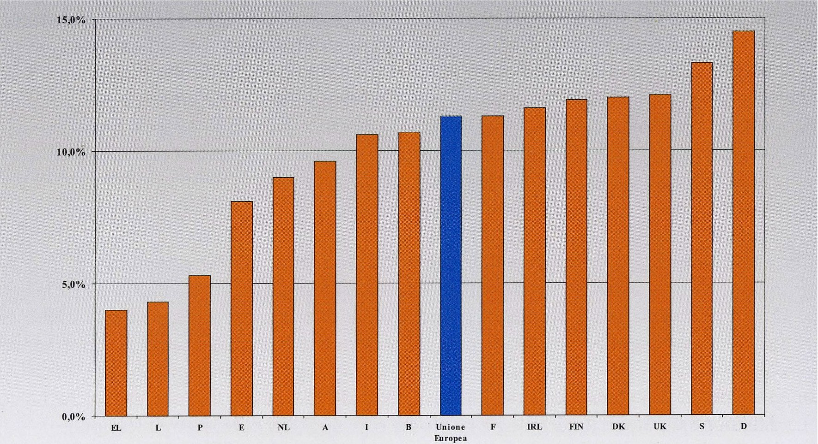

Fig. 2
The creation of new employment in Europe (1995 – 2001).

(Source: Eurostat, LFS – European Commission “Employment in Europe 2002” in Federcomin – Anasin – Assinform Rapporto 2002: Occupazione e Formazione nell’ICT)

According to the data published by EUROSTAT, the percentage of people employed in the ICT in Europe was already 11.3% of the total in 2001, but there is a big difference between the North Europe Countries, France, Ireland and the U.K. and the other European countries; in Italy the percentage of employment in the ICT is of about 10%, if we examine the period 1995 – 2001 we can see that not only employment in the ICT is grown of about 13%, while the total employment has grown only 1.3%, but that the employment in ICT is 10% of the total new employment.

Economic Sector | Net Creation | TCMA | Percentage of New Employment on the Total
Computer and Activities Linked to Computer | 1,166,000 | + 13.6 % | 10 %
Net Total Employment | 11,968,000 | + 1.3 %

Table 2
Creation of new employment in Europe 1995 - 2001 (source: Eurostat, LFS [European Commission, Employment 2002]).

In the ICT sector the sectors software and services are those with the highest number of human resources, and the employment in the software market alone varies from 1% to 2.65% according to the countries. What is also important to stress is that in the ICT sector the professional profiles have been progressively modified, the skill required has grown, while new competences and professional profiles have been created, and, also in sectors that are not strictly ICT, many people have acquired ICT skills in order to improve their management of the new technologies, and, since it is expected that the IT market will grow in the next future, it is foreseeable that the tendency will be kept up both in the improvement of the human resources and in the employment. If we consider the period 1995-2010 in France, Finland, the Netherlands and Spain we can see that the total ICT employment tends to rapidly grow in the boom scenario and it is still positive in the long run in the U.S. recession scenario, even if it suffers some periods of crisis.

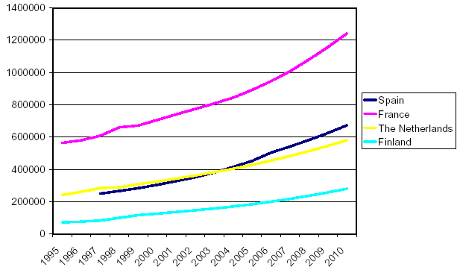

Fig. 3
Total ICT employment in France, Finland, The Netherlands and Spain 1995 – 2010 in the boom scenario.

(Source: Federation of Finnish Electrical and Electronics Industry – ICT Employment Scenario 2010)

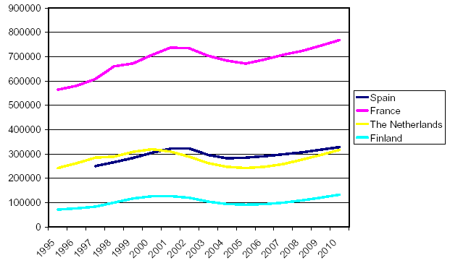

Fig. 4
Total ICT employment in France, Finland, The Netherlands and Spain 1995 – 2010 in the U.S. recession scenario.

(Source: Federation of Finnish Electrical and Electronics Industry – ICT Employment Scenario 2010)

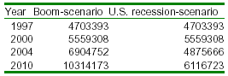
Table 3
Total ICT employment in the E.U. in the two scenarios in 1997 – 2000 – 2004 – 2010 (source: Federation of Finnish Electrical and Electronics Industry – ICT Employment Scenario 2010).

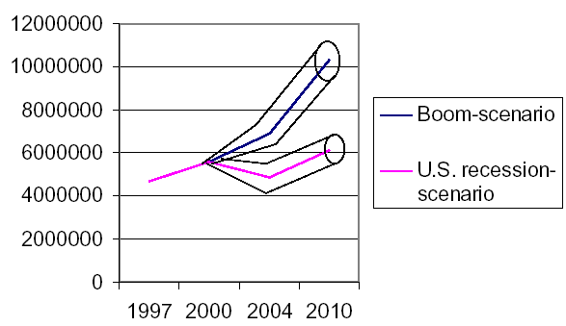

Fig. 5*
Total ICT employment in the E.U. in the two scenarios.
* This graph uses the figures of table 3.

(Source: Federation of Finnish Electrical and Electronics Industry – ICT Employment Scenario 2010)

- A 2-2 Desk market research on ICT, Communication and the New Economy with reference also to the present situation of employment in Italy and in Europe

The starting point for the study of the survey about the employment linked to these sectors is the analysis of the trend in their respective markets and the perspectives of development in the short and medium run. In the uncertain present economic situation, ICT investment are cautious; in 2002, in Western Europe the IT market (including office equipment, electronic data processing and datacom equipment, software and service) was about € 294 billion, while the telecommunication market was about € 298 billion, that makes the ITC market total value € 592 billion, 6.7% of GDP (source EITO 2003).

Table 4
Western European* Information and Communications Technology (ICT) market, 2002, € billion**.
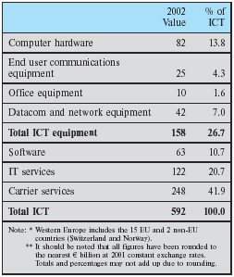

While the IT market experienced a big crisis, due to a decrease in computer hardware and a less than usual growth in software and it services, Telecommunication services continued to have appositive trend, thanks to the demand for data services both in the fixed and wireless environment, (see tables 5 and 6) and, as it is possible to see from the EITO’s data on the period 2000-2004, the telecommunication market is expected to have a positive trend both in Europe and in the rest of the world also in the near future (see table 7).

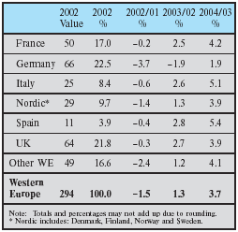
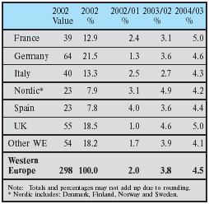

Table 5
Western European IT market by country: percentage breakdown and growth calculated on market values, 2002-2004, € billion.
Table 6
Western European telecommunications market by region: percentage breakdown and growth calculated on market values, 2002-2004, € billion.

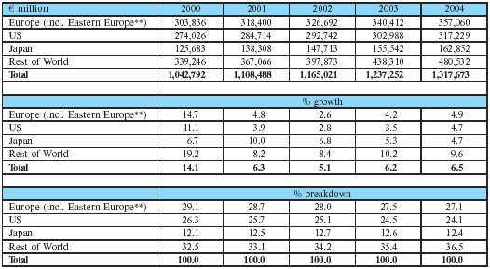

Table 7
Worldwide telecommunications market growth trends. Market value. € million at constant 2001 exchange rates*.

** See Definitions 12.5.5. exchange rates.
** Includes Bulgaria, Czech Republic, Estonia, Hungary, Latvia, Lithuania, Poland, Romania, Slovakia, and Slovenia.

Among all the ICT sectors the one with the faster growth was the carrier service market, whose demand was driven by Internet and online services, its growth was 4.85% in 2002 and is expected to be 4.5% at the end of 2003. In fact since the traditional technologies are rapidly declining, it is incumbent both for companies and single users to adopt new systems despite most of them are struggling with significant medium and long term debts: ADSL, mobile telephone services and new technologies (SMS, MMS [multimedia service] and UMTS), IP VPN and broadband services, cable TV services (CaTV and DTV [digital TV]) are becoming a reality for many people in many countries.

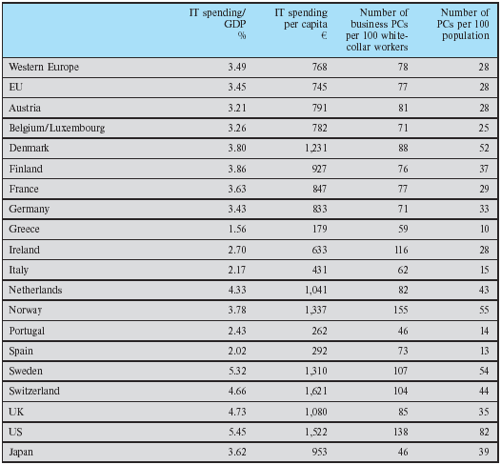

Table 8
IT penetration by country, 2001.

(Source: EITO, IDC (WITSA, Digital Planet), OECD)

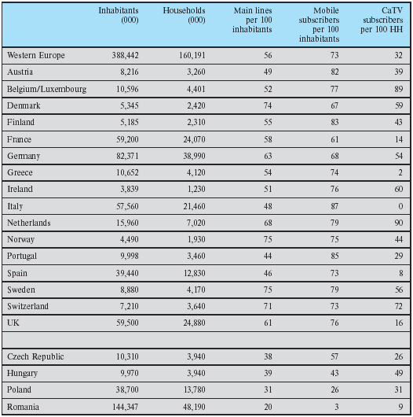

Table 9
Telecommunications penetration by country, 2001.

(Source: EITO Task Force)

If we examine the rate of IT and Telecommunication penetration in Europe, it is interesting to see how Nordic countries continuously reinforce their position against the other European countries both in terms of IT/GDP and IT per capita, while in the GSM market, which is reaching the saturation point in some areas, the Nordic countries are flanked by Italy, but it is important to remember that the mobile sector is increasingly driven by replacements generated by the continuous search of new, last fashion design and the launch of new multimedia services based on GSM/GPRS networks (see tables 8 and 9).
The economic sector that reacted better to the crisis and that showed the highest propensity to invest in IT in 2002 is that of the services, the positive trend is expected to continue in 2003, because government, education, healthcare (because of the need to catch up both with national e-government action plans and the new eEurope Action Plan) and business services investments are strongly influencing the market.
The employment in the sector follows the general economic trend of each segment, showing some difficulties in the recruitment of people with some well-defined skills.
On this point it is interesting to consider the data of the “Rapporto 2002-Occupazione e Formazione nell’ICT” of Federcomin-Anasin-Assinform on the Italian situation. In fact, if we examine the data in the graph (see fig. 6), comparing the percentages per sector in the Netcom and the users, we can see that in general the users have more difficulties in the recruitment of people with the required skills but also the Netcom meet some difficulties because of the numeric lack of skilled professional profiles above all in the fields of Consulting / Planning / Scheduling and of Development / Implementation / Management.

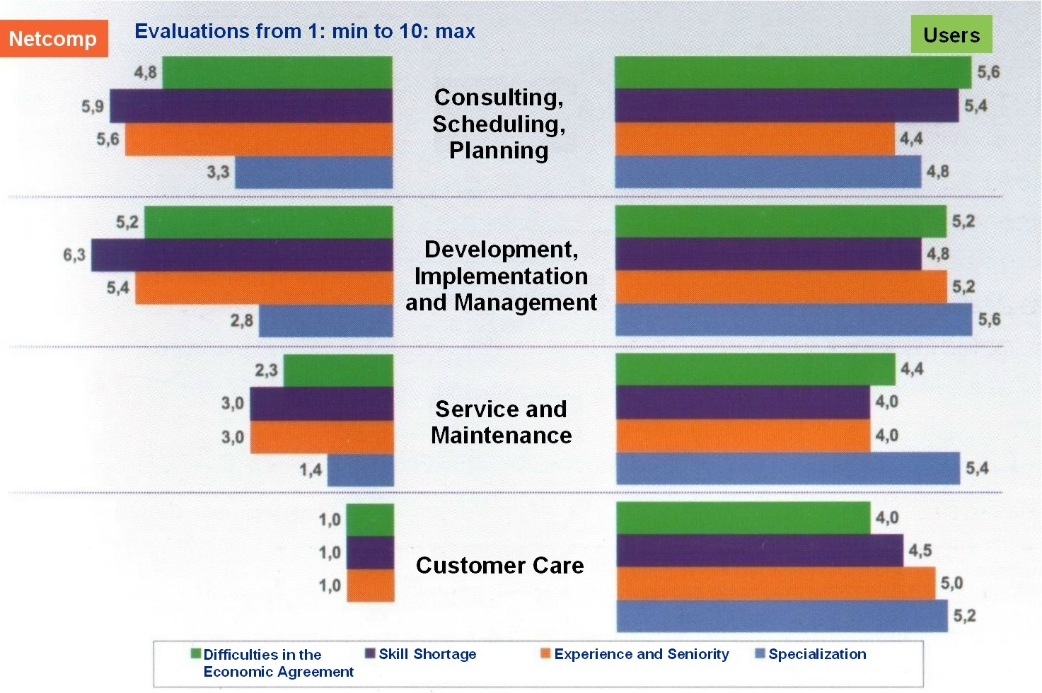

Fig. 6
Difficulties in the recruitment for the ICT skills by the users companies.

(Source: NetConsulting for Federcomin, Anasin, Assinform)

- A 2-3 Desk market research on ICT and media with reference also to the present situation of employment in Italy and in Europe

The media and printing sector is made up of those industries that focus on the creation and the diffusion of content (motion picture and video production as well as publishing), content building (publishing), the production of physical content goods (printing and reproduction of recorded media) and the distribution of content (movie distribution and projection, radio and television activities); according to the e-business W@tch the sector formally includes: publishing, printing and reproduction of recorded media (classified as NACE* 22), motion picture and video activities (classified as NACE* 92.1), radio and television activities(classified as NACE* 92.2).
NACE* Rev.1 | Code | Activity
22 |  | Publishing, printing and reproduction of recorded media
 | 22.1 | Publishing
 | 22.2 | Printing and services linked to printing
 | 22.3 | Reproduction of recorded media
92.1 |  | Motion picture and video activities
92.2 |  | Radio and television activities

Table 10
Definition of the media printing (as used by e-business W@tch).

*Nomenclature general des activités économiques dans les Communautes Européenes (General classification of economic activities in the EC)

According to the e-business W@tch report in the year 2000 this sector alone generated over € 233 billions of product value in the EU countries, Greece and Luxembourg excluded because for them no data were available (see table 13). In the last years the sector has had a very rapid growth, in fact between 1997 and 2000 the production value grew by 53%. We have to consider that the importance of the media sector is linked not so much to its economic importance, which is relatively small, but to its social importance due to its important role for democracy and culture, which pushes all the enterprises involved in this sector, from the smallest to the biggest ones, to a continuous up dating of their IT infrastructures and skills in order to meet the needs of a public that is becoming more and more sophisticated. The e-business W@tch survey, in fact, confirms that in this sector the IT infrastructures are better developed than on the EU-4 (Denmark, France, Italy and U.K.) average, especially for the e-mail and W.W.W. usage. Since there is the necessity of exchange a very large amount of information and data with partners and customers, the Internet connection are more powerful than the average, in fact 57% of employees work in enterprises with DSL or other Non-ISDN fixed line while the average in the EU-4 is 52%.

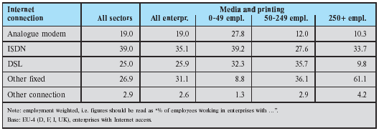
Table 11
Media and printing: Internet connection modus.

All the sector has witnessed a very drastic change in the workflow and in the skills required within the companies and for this reason in the sector there is an high demand for training in the new activities and in the technologies supporting them, since IT skills are required also to people (as the journalists) who have not received a formal schooling in this field; today, above all in the smaller companies, formal training is not regarded as important and the learning by doing is still considered the most useful method for self-learning, while all employees in large companies can count on IT and networking skill development support, on the other hand the usage of working time for learning activities is allowed to a large percentage of employees both in the smaller and in the bigger companies.

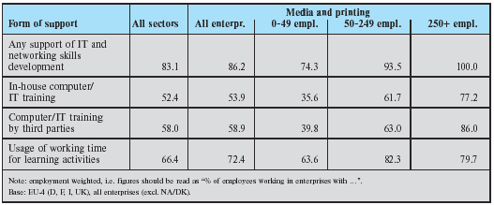

Table 12
Media and printing: IT training support offered to employees.

In Italy there are about 405.000 people working in the sector media/communication whose employment has grown from 373.000 in 1999 to 405.000 in 2002 (source babele s.r.l.). The trends of the sector both for employment and development/creation of skill and technological renewal are still positive in spite of the crisis the ICT sector has suffered in 2001/2. (N.B. Italy is part of the EU-4 analysed by e-business W@tch, see above).

NACE Rev.1 |  | Production value  € (M)* | Production value  %
22.1 | Publishing | 120,858.30 | 51.7
22.2 | Printing and services linked to printing | 99,586.60 | 42.6
22.3 | Reproduction of recorded media | 13,463.90 | 5.8
22 | Publishing, printing and reproduction of  recorded media (total) | 233,909.00 | 100

*EU-13, no data available for Greece and Luxembourg

Table 13
Structure of publishing, printing and reproduction of recorded media in the EU-13 in 2000, by kind of activity (source: EITO2003).

- A 2-4 Desk market research on the “new companies”(linked to the Net Economy) with reference also to the present situation of employment in Italy and in Europe

The sector of the new companies linked to the ICT, that today is living a period of stagnation in some countries, has witnessed a long period of accelerated and in same cases chaotic growth, in Italy for example the number of the companies in the ICT is grown 4.4% in 2000, 3.9% in 2001 and 2.6% in 2002, and the telecommunication companies alone have grown of 8.8%, 11.0% and 6.8% in the same period tanks to the free trade policy adopted by the government in this sector that allowed the creation of new companies in competition with the traditional operators in this field.

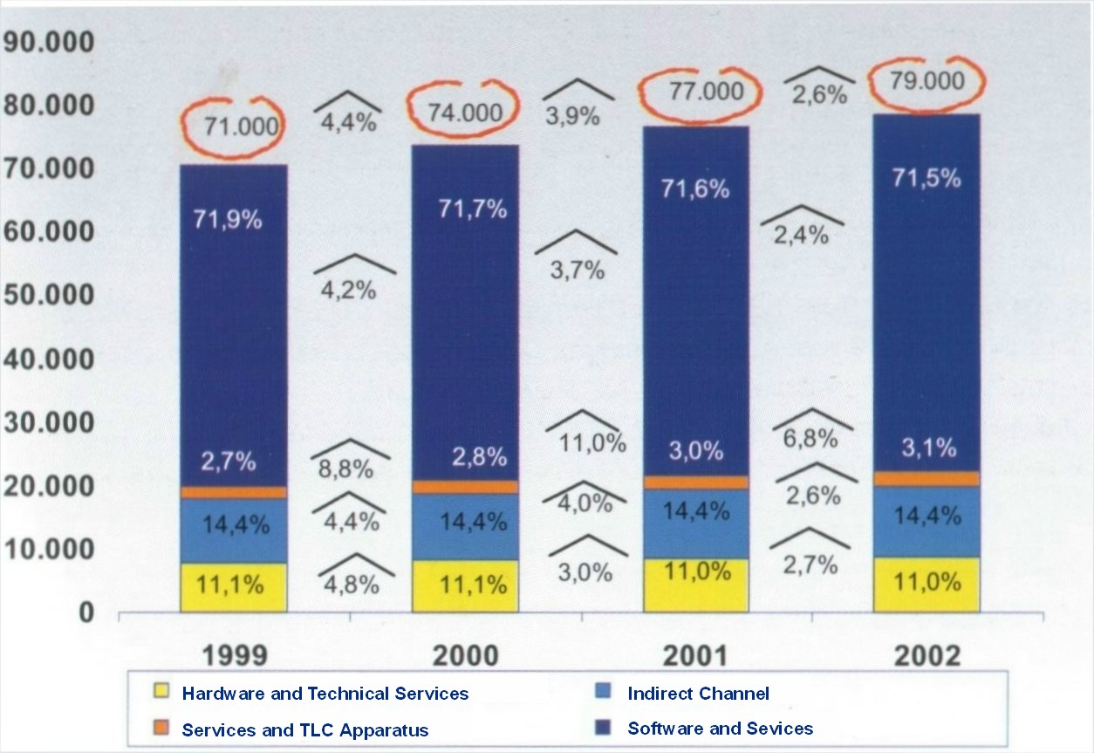

Fig. 7
ICT Companies per Sector in Italy 1999 – 2002 (source: UNIONCAMERE: REA 1999. Elaboration: Survey – UNIMIB).

As from 1999, we have witnessed a lively flourishing of old companies that have converted their production in order to realise telecommunication apparatuses and of new companies of services, also called “Net Companies”, created in the field of the ICT suppliers to offer to users of every kind services and products on Internet. All the sector is characterised by the high number of little companies in which most of the sector employment is concentrated, this characteristic, if from one hand assure a more flexible work market, on the other hand, has a very negative effect on the possibilities of investing in research, development, and technical renewal. At the moment it is difficult to give a detailed description of the new companies linked to the New Economy because, while many new companies appear every day, many other disappear and some more are reconverted in order to meet the public needs better, but one aspect seems to be common everywhere, the hardware and technical assistance sector is the one which is suffering the most the present period of stagnation, while the services, even if with a slower growth, seems to face the crisis better than other sectors.
On this point it is interesting to see the data on the average growth by sectors in Italy in the period 1991-2001 in the annual report on the employment and the training in the ICT by Federcomin-Anasin-Assinform, which shows that, while the average of the new companies in the whole industry and services sector in the period was really slow and of 0.1% in 2002/2001, the growth in the whole ICT sector was 2.6% in the same year and the growth in the services and telecommunication apparatus alone was 6.8 % (see table 14). If we examine the data about the average development of the employment in the same period, in the same country and in the same sectors, it is easily understandable that, because of the crisis, after a long period of fast growth, it is has slowed down (see table 15) but the trend in the ICT sector is still higher than the total one, the total number of the employees in the sector was of about 600.000 people in 2002 (see fig 8), but while many people start working in many others leave or change company and/or professional profile in a rapid turn over (see table 16).

Segments | 1996/1991 | 2001/1996 | 2002/2001
Industry and Services | 2,5 | 0,2 | 0,1
ICT | 7,3 | 6,3 | 2,6
Hardware and Technical Services | 16,7 | 4,2 | 2,7
Indirect Channel | 0,7 | 10,1 | 2,6
Services and TLC Apparatus | 8,0 | 12,1 | 6,8
Software and Services | 7,4 | 5,8 | 2,4

Table 14
Annual Average Rate of Companies Development per Sector and ICT Segments [*], Italy 1991 – 2001.
[*] ICT: Hardware and Technical Services (300, 725), Indirect Channel (51641, 51642, 52481), Services and TLC Apparatus (642, 32202), Software and Services (721, 722, 723, 724, 726).
(Source: UNIONCAMERE: REA, MOVIMPRESE; ISTAT: Censimento Industria e Servizi, Indagine trimestrale Forze di Lavoro. Elaboration: Survey – UNIMIB).

Segments | 1996/1991 | 2001/1996 | 2002/2001
Industry and Services | - 0,5 | 1,6 | 1,5
ICT | - 1,4 | 7,9 | 2,7
Hardware and Technical Services | - 3,9 | 2,1 | 3,0
Indirect Channel | - 1,5 | 11,4 | 1,3
Services and TLC Apparatus | - 4,4 | 5,2 | 0,7
Software and Services | 2,2 | 10,5 | 3,9

Table 15
Annual Average Rate of Employees Development per Sector and ICT Segments [*], Italy 1991 – 2001.
[*] ICT: Hardware and Technical Services (300, 725), Indirect Channel (51641, 51642, 52481), Services and TLC Apparatus (642, 32202), Software and Services (721, 722, 723, 724, 726).
(Source: UNIONCAMERE: REA, MOVIMPRESE; UNIONCAMERE – MINISTERO DEL LAVORO: Excelsior 2002; ISTAT: Censimento Industria e Servizi, Indagine trimestrale Forze di Lavoro. Elaboration: Survey – UNIMIB).

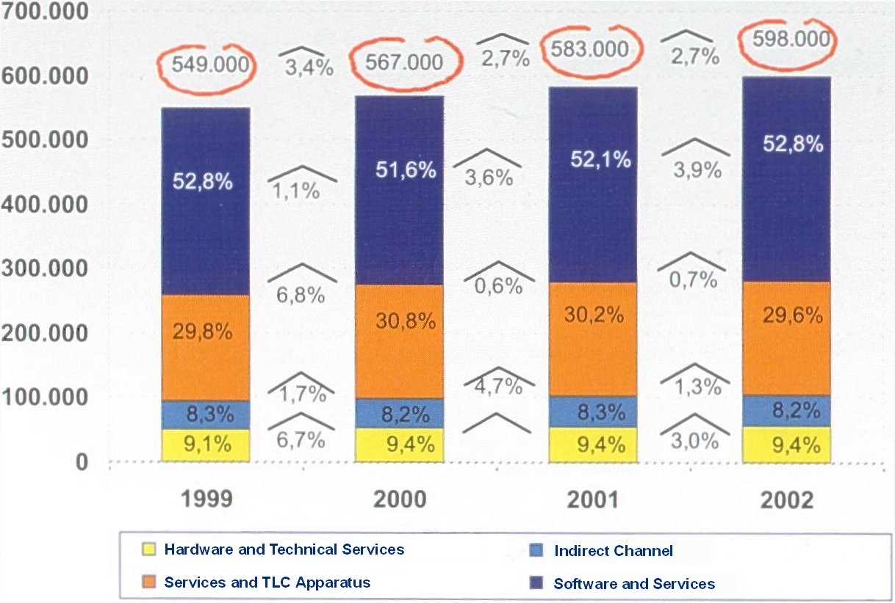

Fig. 8
Employees in the ICT [*] Companies per Sector in Italy 1999 – 2001.

[*] ICT: Hardware and Technical Services (300, 725), Indirect Channel (51641, 51642, 52481), Services and TLC Apparatus (642, 32202), Software and Services (721, 722, 723, 724, 726).

(Source: UNIONCAMERE: REA 1999. Elaboration: Survey – UNIMIB).

 | Entrance Rate | Exit Rate | Development Rate

Distribution per Sector
Total of Industries and Services | 6,7 | 3,5 | 3,2
Industry | 5,6 | 2,9 | 2,7
Services | 7,8 | 4,1 | 3,7
ICT Sector | 6,8 | 3,5 | 3,3
Hardware and Technical Services | 7,7 | 4,5 | 3,2
Services and TLC Apparatus | 3,9 | 3,3 | 0,6
Software and Services | 8,1 | 3,4 | 4,7

Distribution per Dimension
Total of Industries and Services
1 - 9 Employees | 10,4 | 2,3 | 8,1
10 - 49 Employees | 4,3 | 1,9 | 2,4
50 - 249 Employees | 4,7 | 3,9 | 0,8
> = 250 Employees | 6,5 | 6,2 | 0,3
ICT Sector
1 - 9 Employees | 10,0 | 2,0 | 8,0
10 - 49 Employees | 6,0 | 1,9 | 4,1
50 - 249 Employees | 6,9 | 4,3 | 2,6
> = 250 Employees | 6,0 | 4,3 | 1,7

Distribution per Areas
Total of Industries and Services
North - West | 5,8 | 3,4 | 2,4
North - East | 7,0 | 3,9 | 3,1
Middle | 6,3 | 3,2 | 3,1
South and Isles | 8,1 | 3,6 | 4,5
ICT Sector
North - West | 7,3 | 3,7 | 3,6
North - East | 6,1 | 3,2 | 2,9
Middle | 6,4 | 3,3 | 3,1
South and Isles | 7,2 | 3,8 | 3,4

Table 16
Rate of Entrance, Exit and Development of Employees in Industry and Services and of ICT [*] Sector, Italy, 2002.

[*] ICT: Hardware and Technical Services (300, 725), Services and TLC Apparatus (642), Software and Services (721, 722, 723, 724, 726).

(Source: UNIONCAMERE – MINISTERO DEL LAVORO: Excelsior 2002. Elaboration: Survey – UNIMIB).
The same characteristics and the same trend seem to be more or less common to the other European countries with same regional exceptions.

- A 2-5 Desk market research on the new companies (dot com: companies born for the developing of the Internet business) linked to the e-Business
- Enterprise Resource Planning
- Online management of relations with the staff
- Knowledge Management
- Telework
- eLogistic
- Collaborative computing, Workflow, Workgroup
- Supply Chain Management
- On line marketing researches
- Sales Force Automation
- eProcurement
- eGoverment
- eCommerce/Online Banking/Online Insurance
- On line management of R&S projects
- eLearning
- Customer Relationship Management
- Online advertising

One of the most important and recent studies on the present situation on the companies linked to the e-business is that issued by EITO in its annual report (EITO 2003) made by the e-Business W@tch, which was launched by the European Commission, Enterprise Directorate General, in January 2002.
The study covers 15 sectors of the economy, seven manufacturing and eight services sectors.
It was made with the objective of providing information in a sector that was characterised by a lack of reliable information in a comparative international framework about its extend, scope, nature of and factors affecting the speed of its development.
Pushed also by the eEurope Action Plan 2005, whose objective is that of creating a “dynamic E-Business environment to promote take up of E-Business with the aim of increasing the competitiveness of European enterprises and raising productivity and growth through investment in information and communication technologies, human resources (E-skills) and new business models”, many countries are focusing their policy on promoting the new business techniques and the new ways of working.
According to this survey, in 2002, also 94% of the small enterprises (0-49 employees) use computers and 84% of the them have access to the Internet, so the usage of e-mails and of the World Wide Web has become so normal in the world of business that 30% of the enterprises in the sector (accounting for 50% of employment) have realised a Local Area Network (LAN) to connect their computers (see fig. 9).
Recent analysis on e-commerce situation conclude that both in Europe and in the U.S. the take up of e-commerce has not meet the initial expectations since the sector is living particular difficulties, in fact the sector is growing but its growth is much slower than expected.

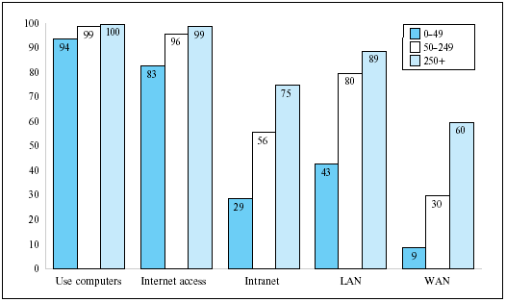

Fig. 9
Basic ICT infrastructure in European enterprises by size (% of enterprises).

[Base: EU-15, all enterprises (n = 9,264)]

This happens also because while, in mid 2002, 94% of enterprises use computers, 84% have access to Internet, 54% have their own website and 36% have created processes for the E-purchasing only 12% use E-commerce to make sales and 46% of these enterprises say that the share of goods and services sold on line is less than 5% of the total, while a further 26% say the share is between 5% and 10 %, but we have to remember that among the problems in this field that of assuring the protection of the customers’ data is among those that more negatively influence the trust of the public (see fig. 10).

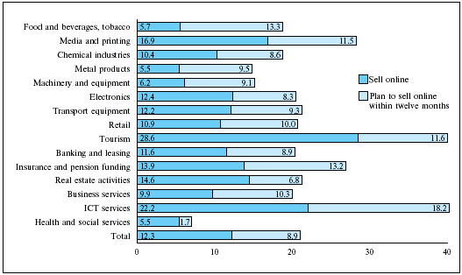

Fig. 10
Companies selling online / planning to sell online within twelve months (% of enterprises)

[Base: EU-4 (D, F, I, UK) (n = 5,917)]

An exception to the slow growth in the sector is the growth of the e-procurement (see fig. 11) since 36% of enterprises and quite half of all large enterprises say they make online purchase of maintenance, repair and operation goods (MRO) or direct production goods, the reasons for this growth are easily understandable since there are the tools needed for its implementation and it offers many advantages in term of costs and time.

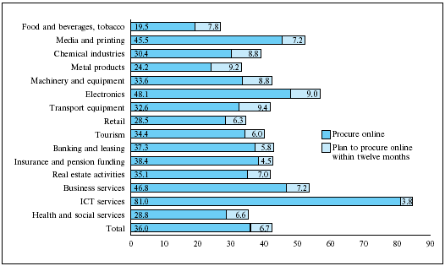

Fig. 11
Companies procuring online / planning to procure online within twelve months (% of enterprises)

[Base: EU-4 (D, F, I, UK) (n = 5,917)]

In general the use of the E-marketplaces (see table 17) is growing slowly also because, as many experts point out, many companies consider the E-business as a parallel activity to their normal activity so they need to integrate their “E” into the general business processes with the support of information technologies and electronic communication networks.

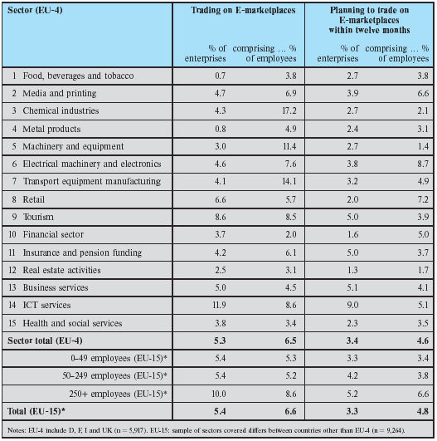

Table 17
Participation in B2B E-marketplaces by sector, 2002

It is still questionable the impact of the adoption of special software for the management of Customer Relations (CRM), Supply Chain (SCM), Knowledge and Enterprises resource Planning, their costs, which include not only the software but also the implementation process, the training and the integration, are still very high and they have in many cases proved to be a disappointment, but many companies still think that they can be the right tool to reduce costs and improve services to the customers because it will be possible to match supply and demand through integrated and collaborative planning tools.

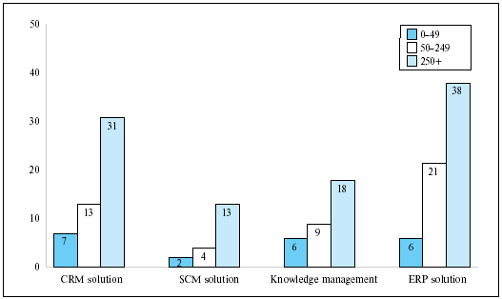

Fig. 12
Diffusion of sophisticated E-business solutions by company size (% of enterprises).

[Base: EU-15, all enterprises (n = 9,264)]

Another sector in which large amounts of money are invested, also thanks to the Community policy, is that of the E-government, E-learning and E-health in all their segments, since they are some of the objectives of the eEurope Action Plan for 2005, that considers the first a fundamental drive for modernising and harmonising public services and, at the same time, for increasing competitiveness in the business sector, and the other two areas as strategic being directly related to the most relevant of all the resources, the human resources; long life learning, skill preparation and mobility plans are decisive in responding to the demography ageing of most European countries and to the requirements for new professional skills and profiles, while an efficient E-health system is fundamental to create an healthy environment and to improve efficiency, reducing the always growing public and private expenses. No reliable data are available for the EU as a whole while the situations of the single states considerably vary, but it is rapidly improving also in those countries, like Italy, that have started their programs only in recent years.

- A 2-6 Desk market research on the “IT, Telecom & Internet Related” in the user companies in Italy, with reference also to the present situation of employment in Italy and in Europe

If we consider the EITO survey for 2003 ( see tables 8 and 9) on the penetration of IT, we can see that in Italy there are 62 business PCs per 100 white collar workers and only 15 PCs per population, while if we consider the data about the telecommunications penetration we have 48 main lines per inhabitants (one of the lowest rates in the EU) but 87 Mobile subscribers per 100 inhabitants (the highest rate in the EU and in the world).
According to the annual report on the employment and the training in the ICT by Federcomin-Anasin-Assinform (see fig. 13), the number of PC per white collar workers grew from 59% in 2000 to 68% in 2001, with the highest growth and penetration in the non industrial sectors, where the average passed from 62.8% to 74.9%.

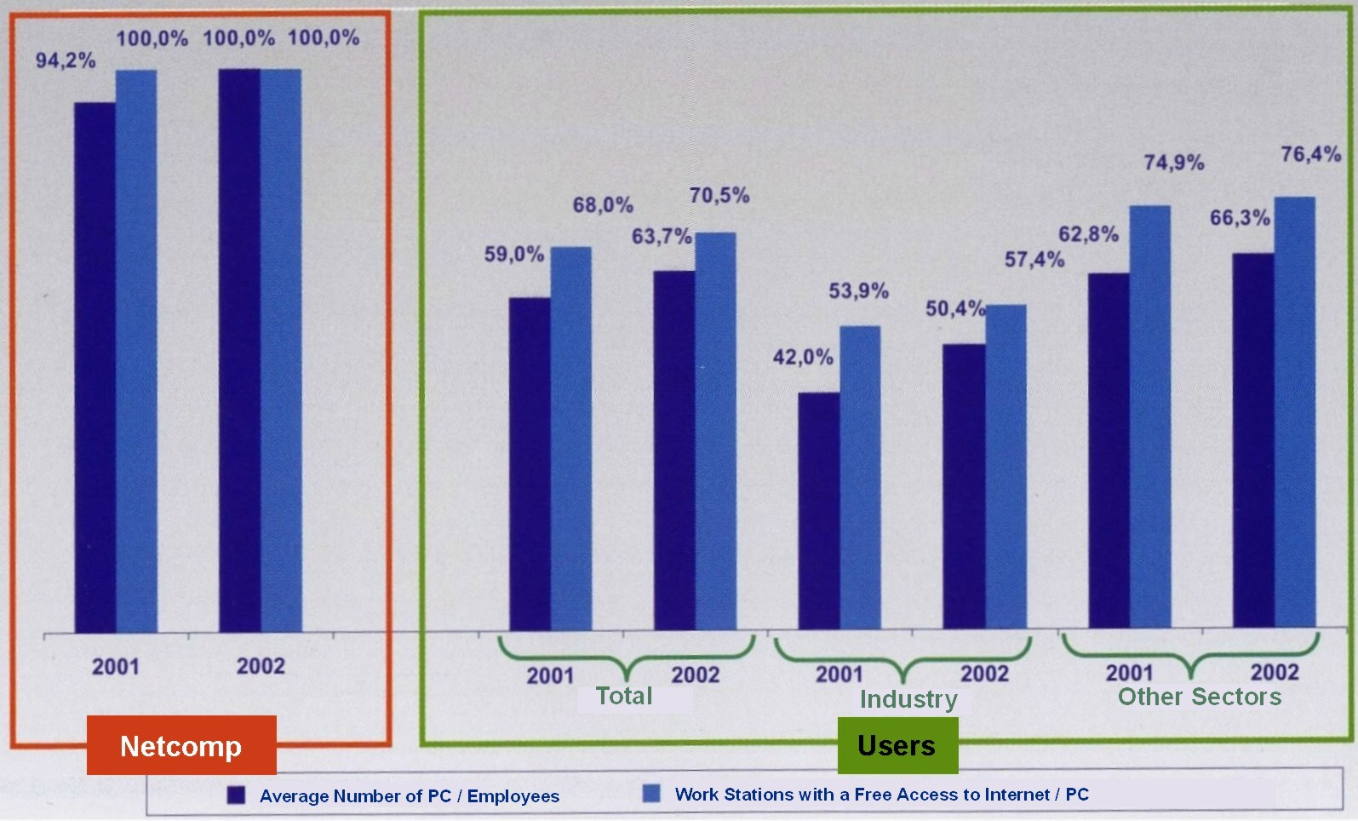

Fig. 13
PC Penetration Level and Number of Work Stations with a Free Access to Internet.

(Source: NetConsulting for Federcomin, Anasin, Assinform)

According to the same survey, in the same period, also the work stations with a free access to Internet passed from 63.7% to 70.5% in the Net-companies alone, while the figures increase if we consider sectors different from the industrial ones, in fact in this case they passed from 66.3% to 76.4%.
In the Net-companies the penetration of the IT is higher than in all the other sectors, since the IT is at the base of the enterprises business, in fact all of them have work stations with free access to Internet, because for them the technologies used and Internet itself are part of the product offered to the customers. For this reason many users companies have implemented divisions with particular technical competences to manage the ICT projects that are considered strategic for the business of the company, while many others have considered the “outsourcing” the better solution to their problems.

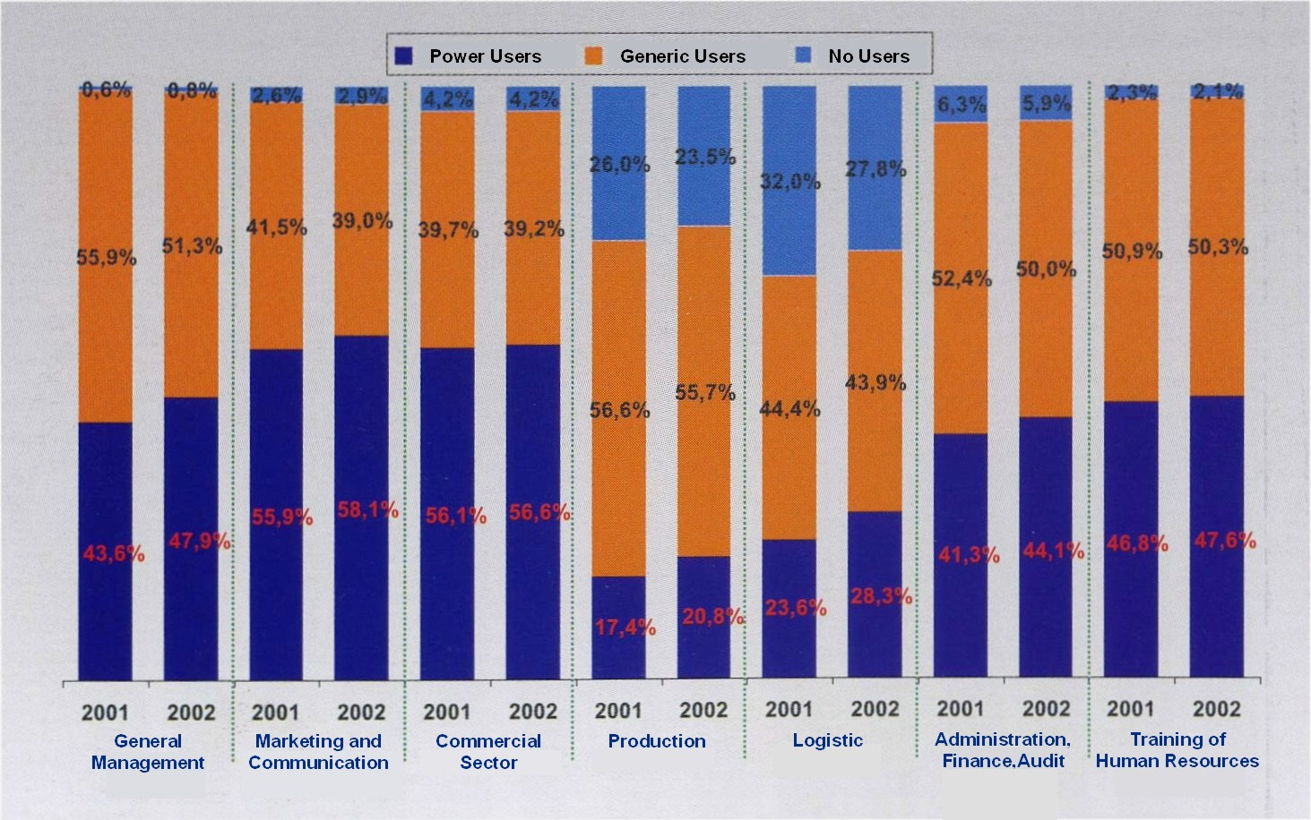

Fig. 14
Power Users and Generic Users in Users Companies Interviewed as % on Total Employees.

(Source: NetConsulting for Federcomin, Anasin, Assinform)
Today a large number of professional profiles with no or little ICT competence are asked to participate and co-operate in the planning of the objectives in the ICT projects for their respective working field and many others are asked to acquire ICT skills in order to manage the new technologies in an autonomous and creative way, for these reasons the demand for training is continuously growing and as a consequence also the number of the Power Users (workers that use the ICT technologies exploiting all their possibilities) is rapidly growing, so as the number of the Generic Users (workers that use the ICT technologies in a more repetitive way and/or use only the tools necessary for their working activity), while the number of the No Users ( workers that do not use IT technologies and solutions) is becoming more and more lower. The main consequence of this situation is that there is a more and more higher request of professional profiles with ICT skills also in sectors that are not strictly ICT, and the companies, that meet skill shortage in the recruitment of some specific professional profiles (see also A 2-2 and A 2-4), very often offer training to fill the skill gap of their employees. The same characteristics and the same trend seem to be more or less common to the other European countries with same regional exceptions.

- A 2-7 Acquisition of data from the research market on the use of Internet in order to know the real incidence that this communicative channel can have on the activities under research also in relation with the future development of the web
- The typology of internet sites on the web, classified according to their sector
- The statistical number of internet users, divided according their category
- The type and the number of the most important firms on the web
- The way in which the web is used
- The future prospective of the web development

The data on the Internet users are unreliable everywhere and often exaggerated. In Italy reliable sources indicate that there are ten or eleven million people on line and that the slower growth of the last period, above all in business, is mainly due to the enormous noise in the media about the financial failure on the stock market, the crisis of the so called “new-economy” and the disappointing results of many poorly conceived online projects.
No reliable data have been found for the typology of Internet sites on the web, since in this sector there is a high rate of turn over, 60% of the sites monitored three years ago do not exist any more, but “babele s.r.l.” counts 513 companies web site only in the ICT, so it is easily foreseeable that the total number is of some thousands. What is really interesting in the data by “babele s.r.l.” is the distribution of the ICT companies with a web site in the Italian provinces, in fact, as it is shown in the table 18, while in the province of Milan there are 138 companies, in more than 50% of the other Italian provinces there are less than 5 ICT companies on the web, and the concentration of the ICT companies in restricted areas of the country is the origin of many problems for this sector, as, for example, the difficulties of recruitment of skilled professional profiles, since often people with the right skill do not want to change their habitual residence and in most of the companies the tele-work is not a reality yet.

Distribution of the ITC Companies with a Web Site in the Italian Provinces
PROVINCE | COMPANIES |  | PROVINCE | COMPANIES
Milano | 138 |  | Forlì | 2
Torino | 37 |  | Imperia | 2
Roma | 35 |  | Livorno | 2
N.D. | 22 |  | Mantova | 2
Napoli | 18 |  | Messina | 2
Firenze | 14 |  | Palermo | 2
Padova | 11 |  | Parma | 2
Treviso | 10 |  | Pavia | 2
Genova | 9 |  | Pistoia | 2
Modena | 8 |  | Ragusa | 2
Bergamo | 7 |  | Reggio Emilia | 2
Bologna | 7 |  | Rimini | 2
Brescia | 7 |  | Udine | 2
Bari | 6 |  | Viterbo | 2
Como | 6 |  | Repubblica di San Marino | 2
Lecce | 6 |  | Agrigento | 1
Pisa | 6 |  | Alessandria | 1
Salerno | 6 |  | Ascoli Piceno | 1
Arezzo | 5 |  | Belluno | 1
Novara | 5 |  | Benevento | 1
Perugia | 5 |  | Brindisi | 1
Pesaro e Urbino | 5 |  | Catanzaro | 1
Avellino | 4 |  | Ferrara | 1
Caserta | 4 |  | Foggia | 1
Cosenza | 4 |  | Grosseto | 1
Cremona | 4 |  | L'Aquila | 1
Cuneo | 4 |  | La Spezia | 1
Lucca | 4 |  | Latina | 1
Trapani | 4 |  | Lecco | 1
Trieste | 4 |  | Lodi | 1
Verona | 4 |  | Massa e Carrara | 1
Ancona | 3 |  | Matera | 1
Asti | 3 |  | Oristano | 1
Biella | 3 |  | Pescara | 1
Bolzano | 3 |  | Pordenone | 1
Cagliari | 3 |  | Prato | 1
Chieti | 3 |  | Ravenna | 1
Frosinone | 3 |  | Reggio Calabria | 1
Macerata | 3 |  | RV | 1
Trento | 3 |  | Savona | 1
Varese | 3 |  | Siracusa | 1
Venezia | 3 |  | Sondrio | 1
Vercelli | 3 |  | Teramo | 1
Vicenza | 3 |  | Terni | 1
Campobasso | 2 |  | Verbania | 1
Catania | 2

Table 18
Distribution of the ITC Companies with a Web Site in the Italian Provinces.

[Source: babele s.r.l.: Programma Leonardo Da Vinci Progetto un Portale per la New Economy Fase 2 (2.2; 2.3; 2.7)]
As we have already said the number of the Internet users is growing with a slower rate than in the previous decade, but an increasing number of people with an Internet access are on line at least once a week, if we consider the survey published, in July 2003, by www.gandalf.it on data by Eurisko it is also possible to see how the Internet activity at home have had a faster growth than those in the office and at school, the last one is that with the slower rate of growth, but the situation is slightly changing in the latest period.

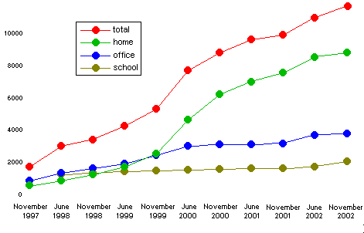

Fig. 15
People Online in Italy 1997 - 2002 (Numbers in Thousands).

(Source: www.gandalf.it on data by Eurisko)

In general we can say that there was a slow growth in 2002 not only in Italy but also in other European countries even if no complete data on the international comparison are available at the moment, but the statistics published by the European Union in 2001 about the 15 EU countries plus the U.S. and Japan shows that Italy is still below the EU average, also because in Italy there are still many people who have a PC but do not have an Internet connection or have a connection but do not use it.

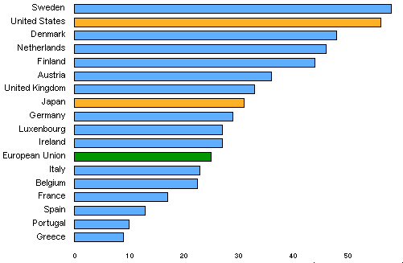

Fig. 16
People Online in Seventeen Countries as Percentage of Population.

(Source: www.gandalf.it on data by Eurisko)

If we consider the number of users by geographic areas we can see that the highest concentration is in the North West of the country, surprisingly followed by Southern Italy, while the North East is the area with the lowest rate of Internet users in the country, while if we consider the people on line by age we can see that the highest number of Internet users is in the age from 25 to 34 followed by those between 35 and 44, the rate of users over 64 is almost zero but the number of young users is continuously growing, and the segment age 24-45 is now about half of the total, this rate becomes even higher if we consider only the frequent users and the people on line at work.

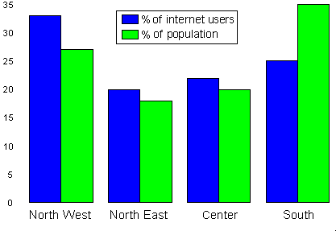

Fig. 17
People Online by Geographic Area as Percentages.

(Source: www.gandalf.it on data by Eurisko)
The use of the Internet is also influenced by the education and income levels, in fact there is an increasing penetration of the Internet users in people with medium (above all upper medium) levels of education and with a medium level of income but there is a higher concentration of “frequent users” among people with a higher income for easily understandable economic reasons.

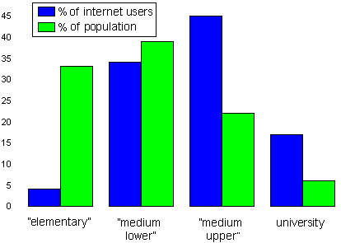

Fig. 18
People Online by Education Level as Percentages.

(Source: www.gandalf.it on data by Eurisko)

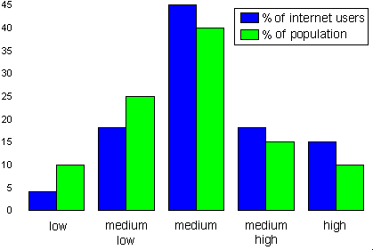

Fig. 19
People Online by Income as Percentages.

(Source: www.gandalf.it on data by Eurisko)

An interesting datum is the increasing number of the women on line, in Italy there are still fewer women on line than in the U.S. and in many other European counties, but in 2002 women were 59% of the “new comers” and are not only youger but also better educated than men.
Italy is at the moment one of the ten largest countries in the Internet, though it is far behind the U.S. and the high-density European counties, but it is also the country with the highest density of mobile telephones in the world, and, while this does not mean that mobile Internet services are likely to become popular, unless there is a drastic change in the price system of these kind of services, this certainly means that the new technologies can grow quickly when they become popular.

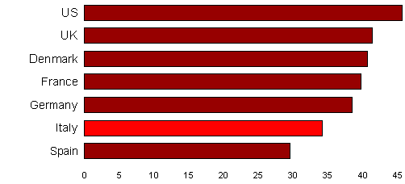

Fig. 20
Women Online in Seven Countries as a Percent of “Internet Users” in Each Country.

(Source: www.gandalf.it on data by Eurisko)

The last aspect that we want to consider about the Internet activity in Italy is the number of the Internet hosts.

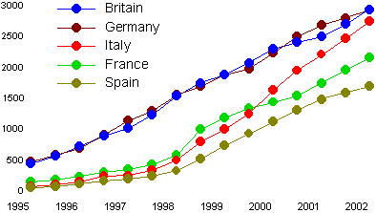

Fig. 21
Internet Hosts in Five European Countries 1995-2002 (Numbers in Thousands).

[In his graph the acceleration of Italy in 2002 is deliberately removed to show the trend as it would be if the Italian hostcount hadn’t overtaken the two traditionally leading countries]

(Source: www.gandalf.it on data by RIPE)

The data on this subject by RIPE (Réseaux IP Européens), analysed and published by www.gandalf.it in April 2003, show how the growth of the Internet hosts in Italy in the period 2000-2002 is faster than in the other EU countries and one of the highest in the world, if we look the graph in fig. 23 we can also see as half of the Internet in Europe is concentrated in only five countries above all in Northern Europe.

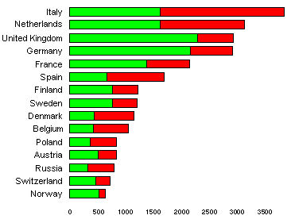

Fig. 22
Internet Hosts (Numbers in Thousands).

[The red part of bars shows growth in two years (from 2000 to 2002)]

(Source: www.gandalf.it on data by RIPE)

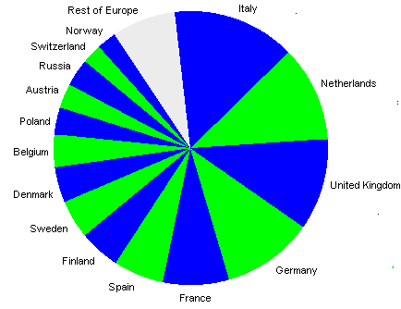

Fig. 23
Situation in the 15 European Countries.

(Source: www.gandalf.it on data by RIPE)

At the end if we consider the data about the Internet hosts per 1000 in 29 counties in the Europe-Mediterranean-Middle East area we can see that Italy is, for the first time, above the average in the EU and this is very promising for the future development of all the sectors Internet related.

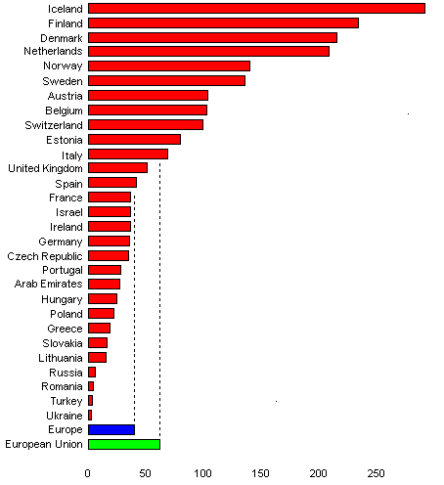

Fig. 24
Internet Hosts per 1000 Inhabitants in 29 Countries in the Europe - Mediterranean - Middle East Area.

(Source: www.gandalf.it on data by RIPE

- A 2-8 Analysis of data acquired through the above-mentioned researches

The above - mentioned research have given a large amount of data that, in this section, have been classified according to specific categories that have a particular importance for the developing of the project.

- Classification of productive, social and cultural environments (divided according to their typology) which need Internet as a new communication media for commercial, advertising, educational, social and cultural purposes and more in general as a new media for global communication.

Productive environments:
- Banking and leasing
- Insurance and other financial
- Manufacturing, transport
- Telecommunications
- Media
- Utilities
- Retail and wholesale (Business to Commerce and Business to Business)
- Business services
- Agriculture
- Constructions
- Mining
- Tourism,
- Real-estate activities

Working environments:
- Banking and leasing
- Insurance and other financial
- Manufacturing, transport
- Telecommunications
- Media
- Utilities
- Retail and wholesale
- Business services
- Agriculture
- Constructions
- Mining
- Tourism
- Real-estate activities
- Government
- Employment agencies
- Training agencies, institutions and organisations

Social environments:
- Central government
- Local government,
- Healthcare and social services
- Media
- Institutional agencies and offices
- Religious institutions
- Tourism and leisure time

Cultural environments:
- Education (training agencies, institutions and organisations, schools, universities)
- Sports
- TV and radio
- Cinema
- Theatres
- Music
- Danse
- Arts,
- Literature
- Libraries
- Bookshops
- Museums
- Publishing

- Classification of new activities directly linked to the opportunities offered by the New Economy, as start up of new companies, as spin off of innovative activities in existing companies, development of services as support of new solutions and ICT applications.

- Fixed and mobile telephones (infrastructures and services)
- Telecommunication network [(LAN and WAN), infrastructures, services and on line services]
- CaTV services
- Network design and administration
- Satellite network
- Hardware and software planning and realisation
- Customer care
- Research and development
- Technical assistance
- Enterprises systems
- Digital media
- On line management of: staff, staff recruitment, staff training, research, production, sales, supply, customers, customers care, communications, training, business administration, advertisement, knowledge, procuring, electronic exchange of documents and on line negotiation of contracts
- Access to intranet and extranet systems

- Actions for the diffusion in the “user firms” (i.e. generically, firms which use information technology and Internet) of an Internet related culture and knowledge, not only for the management of new technological platforms but also, and above all, for a new management of their business.

- eEurope Action Plan 2005
- Training of staff
- New procedures management
- New business management
- Introduction of new technologies and software
- Recruitment of external services and skilled staff

- Classification, according their field of action (commercial, advertising, educational, social and cultural), of technical and technological interventions which can be efficient for every reality Linked to the New Economy.

Introduction of:
- Hardware
- Software
- New skills
- Infrastructures (semantic web [Intelligent Software Agents], broadband, mobile and satellite networks)

- List of services and technologies linked to the Net Economy (traditional ICT industry) offered.

Services:
- Communication, advertising and marketing
- Commercial
- Consulting, scheduling and planning
- Development, implementation and management
- Maintenance and services
- Customer care
- Research and development
- Management of staff, administration and finance
- Human resources

Technologies:
- Hardware and software systems
- Workstations
- Workstations adds-on
- Telephones sets
- Mobile telephones
- End-users communication equipment
- CaTv services
- Office equipment
- Data-com and network equipment
- Software products
- IT services (telephone and mobile telephone services, switched data and leased line services)
- Internet and on line services

- List of services and technologies linked to the m-commerce (mobile commerce).

Services:
- Mobile e-mail
- Mobile sale force automation (MSFA),
- Mobile directories
- Mobile collaborative
- Mobile customer support
- Mobile hotdesking
- Mobile payments
- Mobile commerce
- Mobile supply chain automation (MSCA)

Technologies:
- Hardware and software systems
- Workstations
- Workstations adds-on
- Telephones sets
- Mobile telephones
- End-users communication equipment
- CaTv services
- Office equipment
- Data-com and network equipment
- Software products
- IT services (telephone and mobile telephone services, switched data and leased line services)
- Internet and on line services

- Identification of borders between specific segments of the ICT industry (field of services liked to Internet and to the wireless) and of media, thanks to the development of the “digital convergence”.

- Entertainment on demand
- Culture on demand
- Information on demand
- Education on demand
- CD-ROM, DVD, e-book
- Any support of IT and networking skills development
- IT training
- Publishing
- List of the existing professional profiles and of those that will be required in the next future,
as they are deduced by the data analysis.

Existing:
- Integration and Test Engineering
- ICT Marketing Management
- Multimedia Design
- System Specialist
- Software and Applications Development
- IT Business Consultancy
- Communications Network Design
- Data Communications Engineering
- Product Design
- Software Architecture and Design
- DSP (Digital Signal Processing) Application Designer
- Digital Designer
- Radio Frequency (RF) Engineering
- Technical Support
- ICT Project Management
- Research and Technology Development
- ICT Management
- ICT Sales management
- ICT Security

Future:
- Specialist of e-commerce for tourism
- Specialist of information methods and solutions for the customer care
- Expert in multimedia languages and technologies
- Web specialist
- Specialist of the web area for the e-commerce
- Web editor
- Incoming programmer
- Technician for telematics
- Expert of multimedia communication for the agencies of tourist intermediation
- Web master
- Company’s system manager
- e-business marketer
- Specialist in office automation
- Doctor PC-operator for information help desk
- Data entry programmer
- Web marketing
- Horizontal and vertical portal manager
- Commercial promoter on line
- Web solutions developer
- Graphic Arts Designer for the sector “Beni Culturali”
- Operator in the tele-assistance for old people
- Software programmer in object oriented environments
- Net-working experts
- Experts in advanced multimedia instruments
- Operator of the multimedia communication
- Visual programmer in RDBMS environment
- SAP SEM expert
- Computer programmer in UNIX environment
- Networks planner (Windows/Unix/data base)
- Description of the existing and future professional knowledge, competence and ability for the professional profiles linked to the New Economy.

- ICT skills
- Knowledge of the most common software on the market
- Transversal competences, which allow people to use and adjust the existing software according to the customer’s requirements
- Knowledge of the specific sector in which the ICT competence must be applied (commerce, finance, tourism, etc.)

- Identification of the communicative channel (commercial, advertising, educational, etc) needed for each sector under research for a more efficient interaction between the poles of the communication (firm-customer, public institutions-citizens, teacher-student and many others that will be deduced by the research data).

The communicative channel which is considered able to offer the most effective and efficient interaction between the poles of the interaction for all the sectors under research is Internet in its broadband and wire less versions.

- Syllabus of the main professional profiles
(Link to the folder of the professional profiles)

BIBLIOGRAPHY

- Allweb Solutions S.A.: Phase 2 – A Portal for the New Economy

babele s.r.l.: Programma Leonardo Da Vinci Progetto un Portale per la New Economy Fase 2 (2.1;2.2; 2.3; 2.7)
- BDF- Balear de Desarollo Y Formación: Informe Sobre la Situación de la Sociedad de la Información y las TIC en España
- E.S.S.I.: Phase 2 – Un Portale per la New Economy
- Rapporto 2002 - Occupazione e Formazione nell’ICT - A cura di Federcomin, Anasin, Assinform in collaborazione con ESDW/UNIMIB-Unioncamere - NetConsulting
- Rapporto Federcomin 2002-E-business: Realtà e Prospettive - A cura dell’Ufficio Studi Federcomin, in collaborazione con IDC Italia
- EITO 2003 European Information Technology Observatory – 11th ed.
- Pivi Peltola, Mari Tammi, Sami Leppimãki and Tarja Meristõ: ICT Employment Scenarios 2010 – The Future Scenarios of the Employment in the European ICT Sector – 2001 for the Federation of Finnish Electrical and Electronics Industry
- www.federcomin.it
- www.eurostat.com
- www.istat.it
- www.smau.it
- www.eurisko.it
- www.agcom.it
- www.cnel.it
- www.ancitel.it
- www.gandalf.it
- www.ebusiness-watch.org
- www.ecommerce.gov.tt
- www.unioncamere.it
- www.confindustria.it
- www.ocse.org
- www.minwelfare.it
- www.censis.it
- www.italia.gov.it
- www.anci.it
- www.ict.job.it
- www.parlamento.it
- www.coe.int
- www.europa.eu.int
- www.google.it
- www.comunicazioni.it
- www.minindustria.it
- www.funzionepubblica.it
- www.palazzochigi.it
- www.istruzione.it
- www.cantieripa.it
- www.crcitalia.it
- www.innovazione.gov.it
- www.wto.org
- www.assinform.it

